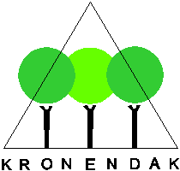
Grant application Stichting Het Kronendak
1. Project title:

2. Project location:

3. Start and end dates:

4. Personal details:
Name:
Address:
Current institution/university:
Current position:
Phone:
Email:
Bank account (IBAN, BIC):

* By submitting this application form, the applicant consents to the processing of her/his data for administrative purposes within the framework of the AVG guidelines.

5. Target of the project
Intership/MSc-thesis/PhD/Other: ….
Is this project part of a larger research project? If yes, which one:
6. Project budget (as example, can be adjusted to the project)
Costs |  | Funding
Transportation | € | Requested from SHK | €
Accomodation | € | Personal contribution | €
Materials | € | Other funds:
Other ………… | € | ……………………..((already granted?) | €
Other …………. | € | …………………….. (already granted?) | €
 |  | …………………….. (already granted?) | €
Total costs estimated | € | Total funding | €

7. Brief explanation of the proposal (max 1 A4 in Dutch or English) with:
- A summary of problem statement and hypothesis or objective and scientific interest, and a summary of the project (social interest)
- The link with the forest canopy
- The methods of the project
- The expected output (publication, report, or otherwise) of the project and the possible impulse that the project generates (continuity, expansion locally, expansion elsewhere)

The conditions for a subsidy from Stichting Het Kronendak can be found on the website. The completed application form together with the applicant's CV, a short motivation and a short research or internship plan must be submitted by e-mail to info@kronendak.nl.

